**Project title:** Visualize Customer Emotions during Chat Bot conversation

**Project objectives:**

1. Adding total utterance per user and average angry score and average happy score per user.

Screenshot:

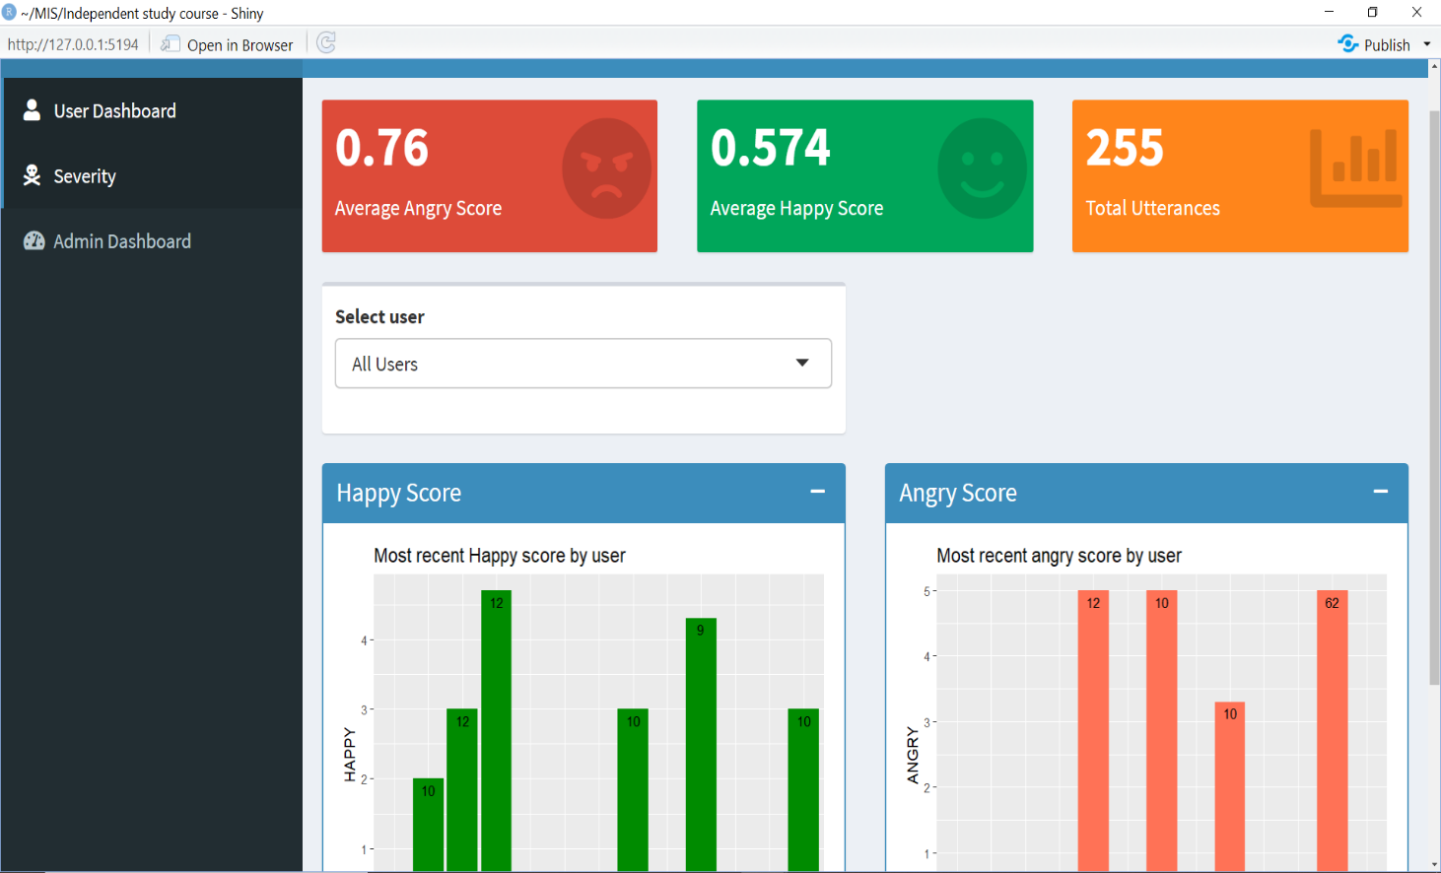

Explanation:

Here, the value box in orange color is displaying total utterances of all users. When you select any other user then the corresponding utterances will be displayed for the selected user. Also, the value box in red and green are displaying average angry score and happy score for all users.

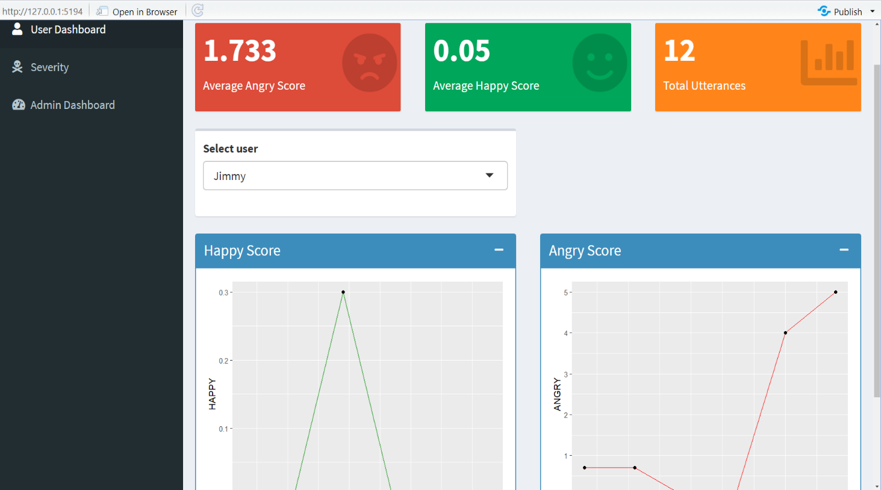

As per the screenshot, we can see that total utterances, average angry score and average happy score values are dynamically changing when another user is selected and so on.

2. We will add alert system or notification that is triggered when a conversation falls in red severity level along with time and date details.

Screenshot:

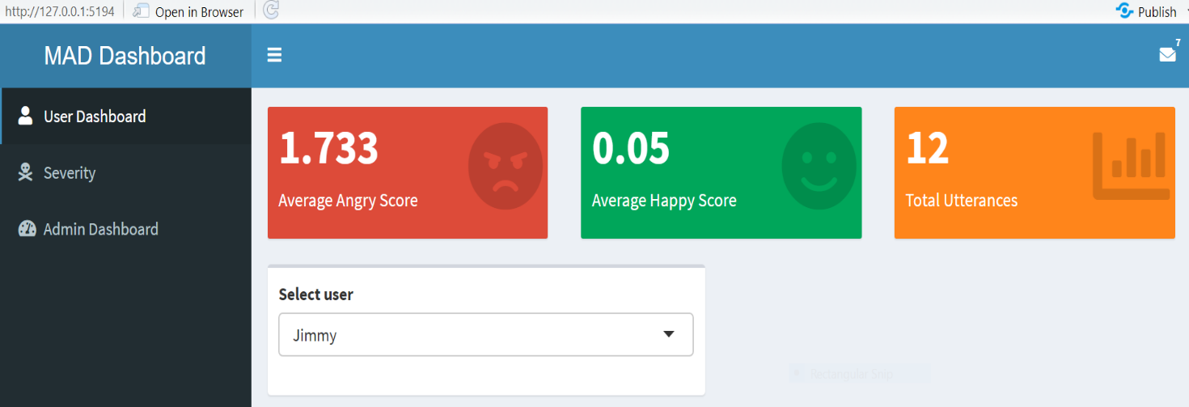

Explanation:

In the above screenshot , Notification type ‘messages’ are added at the top of the menu bar

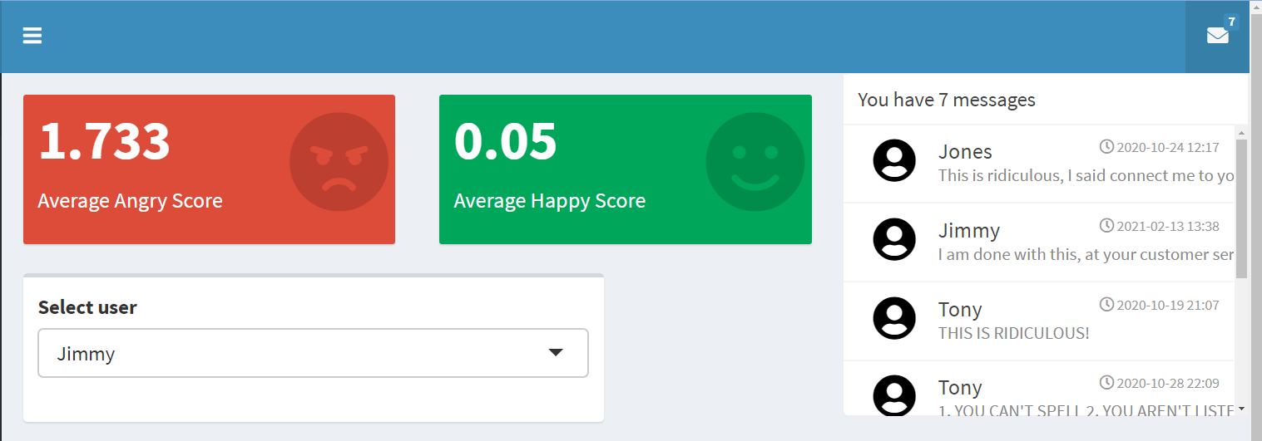

When you click on the message notification, the utterance that is under red code is displayed here which means the utterance is of severity 5 along with username. We have also added date and time of the utterance so that it allows us to prioritize based on the time.

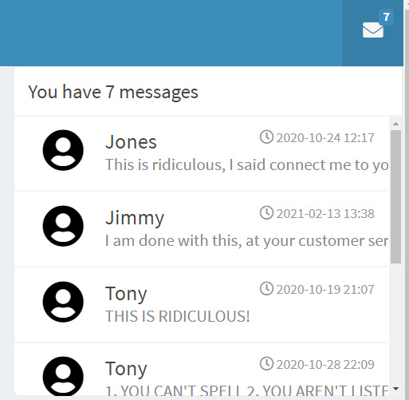

3. Adding running average angry score per user along with last angry score per user

This bar graph is in the severity tab that shows the running average of last 3 angry score per user along with the last utterance angry score.

Example - Below image shows Jimmy’s last angry score was 5 and average of last 3 angry score was 3.

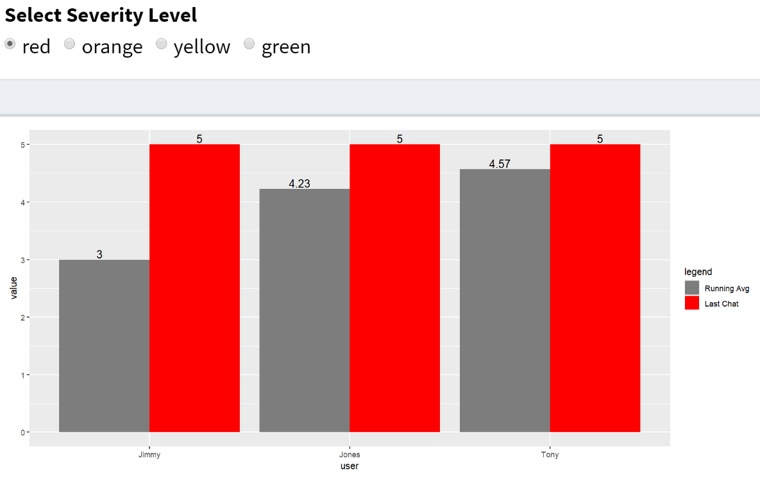

Here Mike’s average of last 3 utterance is 2.1 and his last angry score is 3.3

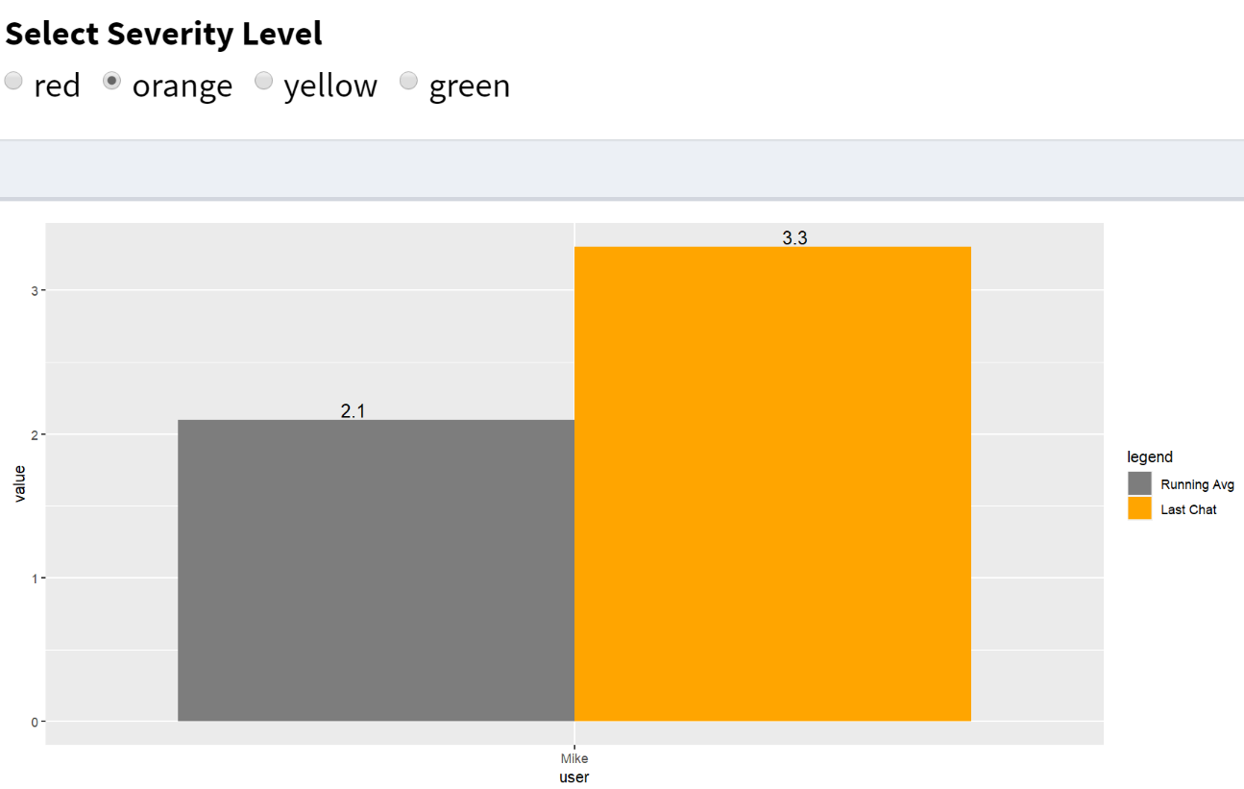

Click on the username to view the conversation between the user and bot. It will display the last 6 conversation.

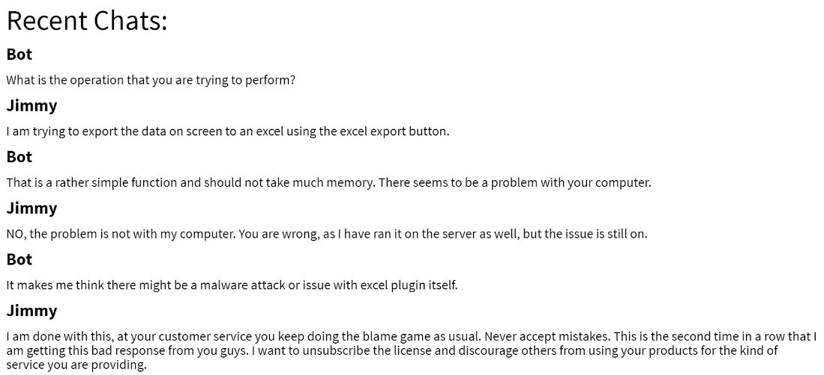

Below two screenshots are from the admin dashboard tab:

The following line graph shows the trend of average and max angry score and happy score for the bot in last 10 minutes.

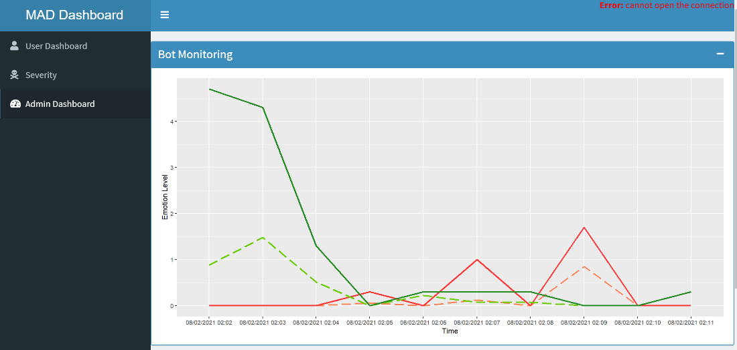

The following line graph shows the trend of average and max angry score and happy score for the users in last 10 minutes. (Working on displaying the legend for the graphs)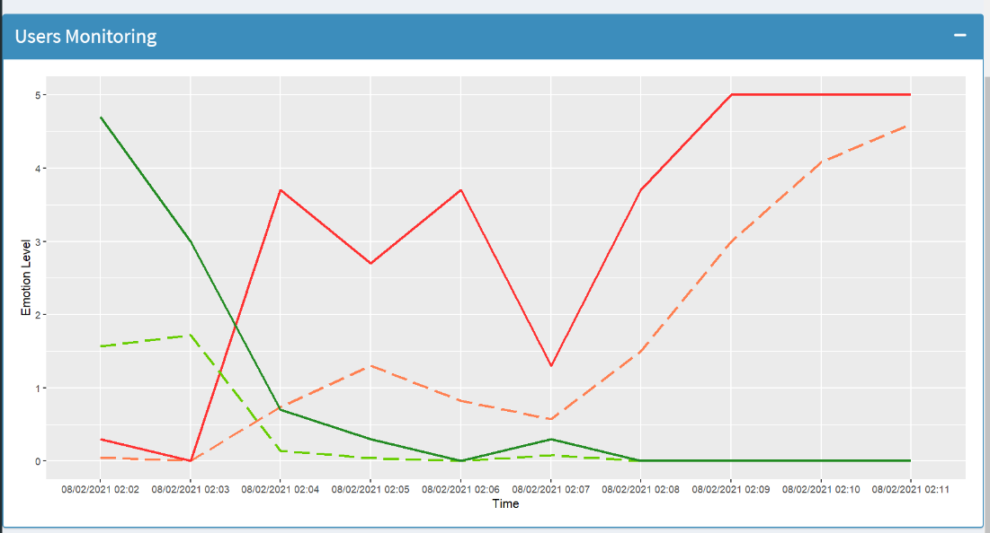

Note- We are working on adding word cloud to the admin dashboard.